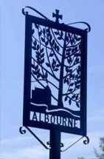
ALBOURNE PARISH COUNCIL
Invites you
To the Annual General
Meeting of the Parish
on Tuesday, 7th May 2024
at 7.30 p.m. in the Village Hall
_________________________________
The Agenda for the meeting will be published on
the 25th April 2024, and the draft minutes of the May 2023 meeting will be posted up on the Parish Council’s website prior to this meeting.
We hope that you will be able to join us
for the meeting, as this is your chance to have your say, with Parish, District and County Councillors present, on any issues
that concern or affect you!
Albourne Parish Council
Dated: 18th April 2024

